**Name: Mary Taiwo Omotoso**

**Course: WDD 330**

1. **Overview**: This **Housing Agent app** is designed to solve the common challenges faced by real estate agents and house renters or buyers. This is the problem of long channel of agent when a certain buyer is trying to rent or buy a property. Also, the problem of proper marketing and customer service. The motivation is to solve the above-mentioned problems as well as help reduce every other anomaly in property acquisition at the local level. It will also improve client experience using real-time listings and better communication tools.
2. **Target Audience:** Real estate agents/agencies, prospective property buyer/renter, real estate marketers and property owners looking to list.
3. **Major Functions**:

* User login: This is registration for both the seller and the buyer. The agents do the listing while the clients do the search and enquiry.
* Listing management: The agents do the upload, description and the over all management of each item on their dashboard.
* Enquiry: Clients will make a search and filter available properties according to their desired features like amenities, type of property, location etc.
* Live map view: Clients can view properties using google maps and a live location API.
* Chat: Both the agent and client can have lengthy discussions to reach agreement on their deals.
* Document Upload and Management: Agents will be able to upload related documents for the property while the system generates watermark to reduce photo theft.
* Saved Listings: Clients can save already viewed property they are interested in to revisit it and compare it also to receive update in price change.
* Rating System: After a successful transaction, clients can leave a rating star and review about the agent.

1. **Wireframes:** 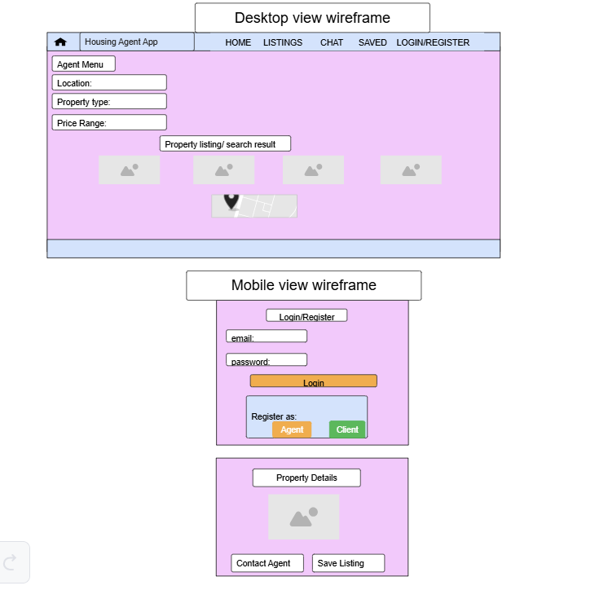
2. **External Data**:

Google Map APIs for live location tracking of the property and for user location too.

User profile for both agent and client information.

Chat logs

Inquiries

Property listings

1. **Module List**:

Authentication module

Listing module

Chat module

Map integration module

Search module

Rating module

Saved items module

Document management module

1. Graphic Identity:

Color: primary – soft navy blue #34495E for header and nav. Secondary – warm gray #BDC3C7 for backgrounds and sections. Ascent: coral #E67E22 for call-to-action button.

Typography: roboto for headings and open sans for body.

Application icon: a house icon.

1. Timeline:

week 5

project set up

creating dashboard layout

nodes.js authentication

week 6

search UI

chat module

google map APIs

week 7

add chart using chart.js

responsive designs

deploy to Netlify

user testing.

1. Project Planning: [WDD 330 | Trello](https://trello.com/b/DCFFsJby/wdd-330)